**CC-215-L: Database Systems Lab**

*Faculty of Computing & Information Technology*



**BS(CS) Morning - Fall 2021, Semester Fall 2023**

**LAB – 02**

# Topics

* SELECT statement
* Arithmetic Operators
* Column Alias
* Relational Operators
* Logical Operators
* WHERE clause
* Special comparison operators (BETWEEN, IN, LIKE, IS NULL)
* Concatenation Operator (||)
* Use of DISTINCT
* ORDER BY clause

# Learning Objectives

* Develop the fundamental skills of data retrieval
* Performing arithmetic operations
* Restricting the selection of rows
* Learning the elegant ways for data retrieval using special operators
* Eliminating duplicate values using DISTINCT keyword
* Labeling of columns and expressions
* Sorting the output

# General Instructions:

* In this Lab, you are **NOT** allowed to discuss your solution with your colleagues, even not allowed to ask how s/he is doing; this may result in negative marking. You can **ONLY** discuss with your Teaching Assistants (TAs) or Lab Instructor.
* Your TAs will be available in the Lab for your help. Alternatively, you can send your queries via email to one of the followings.

|  |  |  |
| --- | --- | --- |
| **Lab Instructors** | | |
| Course Instructor | Dr. Asif Sohail | [asif@pucit.edu.pk](mailto:asif@pucit.edu.pk) |
| Teaching Assistants | Kabeer Ali | [bitf20m018@pucit.edu.pk](mailto:bitf20m018@pucit.edu.pk) |
| Hamza Farooqi | [bitf20m031@pucit.edu.pk](mailto:bitf20m018@pucit.edu.pk) |

Hope you are fine and feeling yourself comfortable and exciting to play with Structured Query Language (SQL) in this first lab. *You have been taught in the lecture about SQL and query writing. Why not to get all what you have learned with a hands-on experience?* So, let’s Start!

*Allowed time: 1.5 hour*

***Note: Do follow these instructions while you are sitting in the lab and performing the tasks.***

1. ***Gossips are not allowed. So be gentle and do what you know. The lab is not to deduct your sessional marks but to prepare you to achieve good marks in quizzes, mids and finals and finally have good grades. So, try to perform all your tasks in time and at your own.***
2. ***Teacher assistants are for your help, so be nice with them. Respect them as they are teaching you. Raise your hands if you have some problem and need help from TA. Avoid calling them by raising your voice and disturbing the environment of Lab.***
3. ***You must revise the content of the past lectures before starting the lab, it will help you resolve most of your general queries and give you the confidence that you can do it.***
4. ***Evaluation will be considered final and you cannot debate for the marks. So, focus on performing the tasks when the time is given to you.***
5. ***TA may deduct your marks for any kind of ill-discipline or misconduct from your side.***
6. ***Finally, pray before you start. And, Best of Luck!***

* **Kindly paste the query as well as result table screenshot as a result of each task**

**Sample:**

**Display All the Employees from emp table**

**Solution:**

**Select * from emp**

|  |  |  |  |  |  |  |  |
| --- | --- | --- | --- | --- | --- | --- | --- |
| **EMPNO** | **ENAME** | **JOB** | **MGR** | **HIREDATE** | **SAL** | **COMM** | **DEPTNO** |
| 7369 | SMITH | CLERK | 7902 | 12/17/1980 | 800 | - | 20 |
| 7499 | ALLEN | SALESMAN | 7698 | 02/20/1981 | 1600 | 300 | 30 |
| 7521 | WARD | SALESMAN | 7698 | 02/22/1981 | 1250 | 500 | 30 |
| 7566 | JONES | MANAGER | 7839 | 04/02/1981 | 2975 | - | 20 |
| 7654 | MARTIN | SALESMAN | 7698 | 09/28/1981 | 1250 | 1400 | 30 |

**Task 01: [15 Marks]**

1. List all CLERKs working in either deptno 10 or 20.

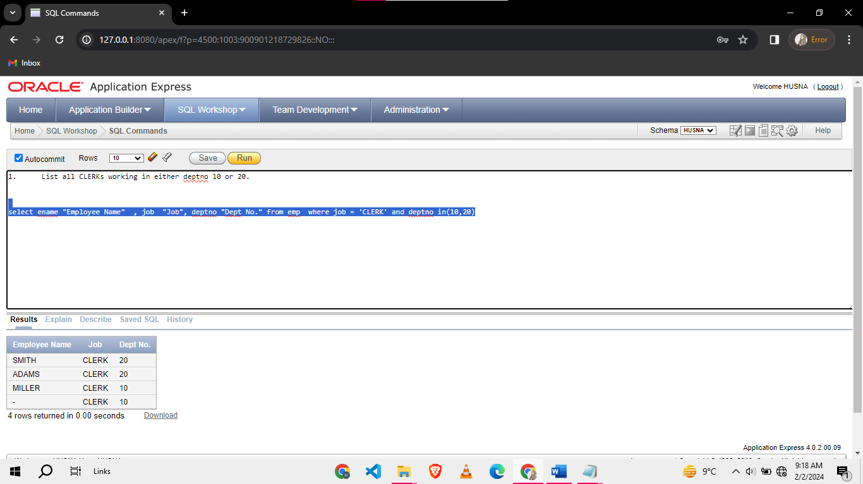

1. List all MANAGERs with salary in the range 2000 to 3000.

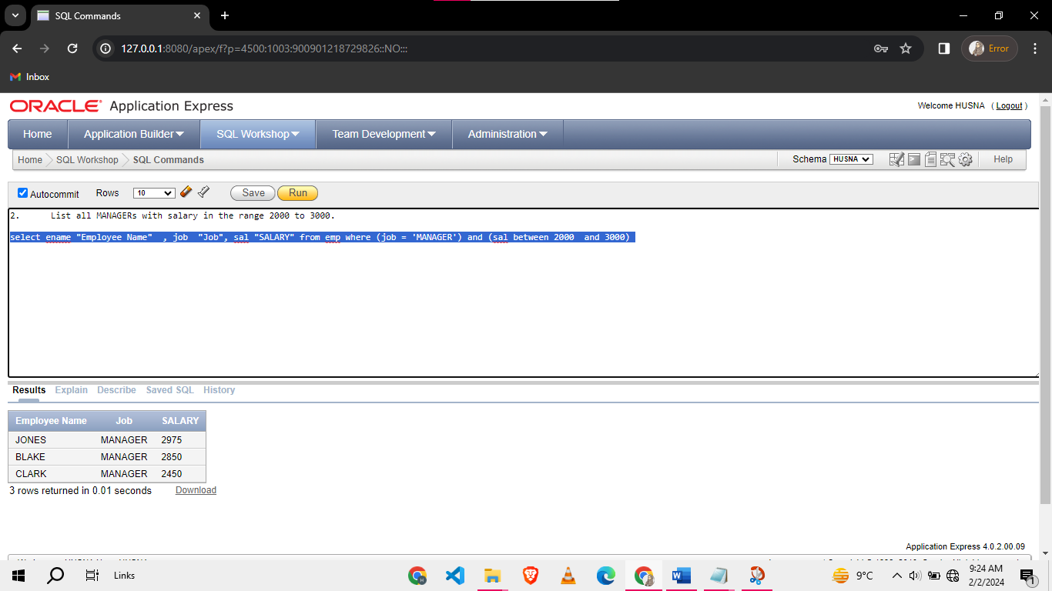

1. List all employees who are not SALESMAN and their name starts with S.

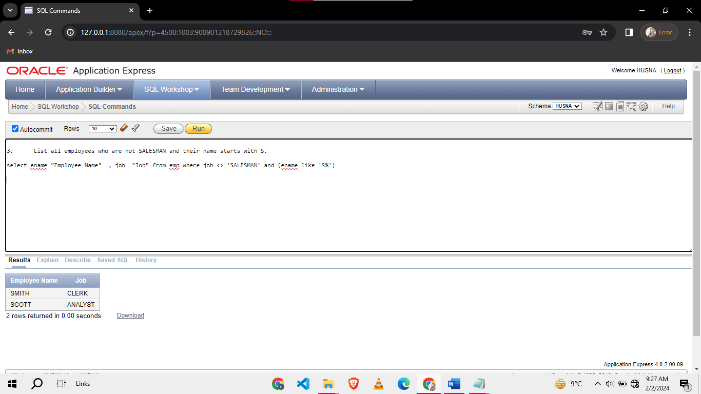

1. Using SQL statement find out how many months have passed since the day you were born until today. Name the column ‘Month’s Old’

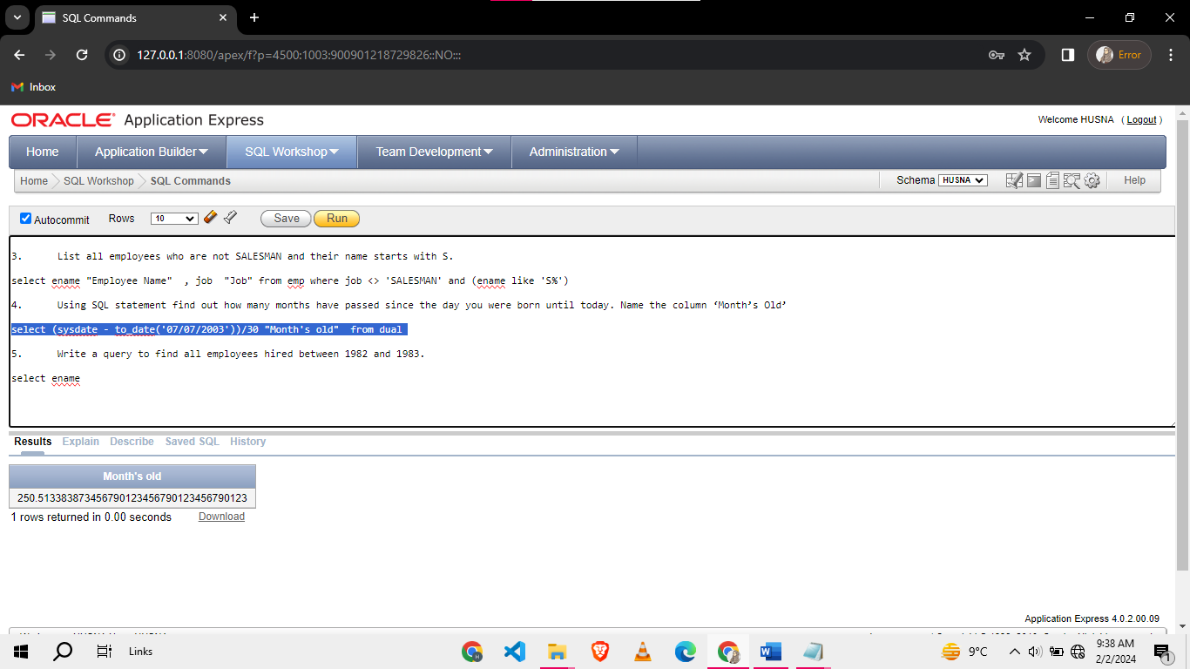

1. Write a query to find all employees hired between 1982 and 1983.

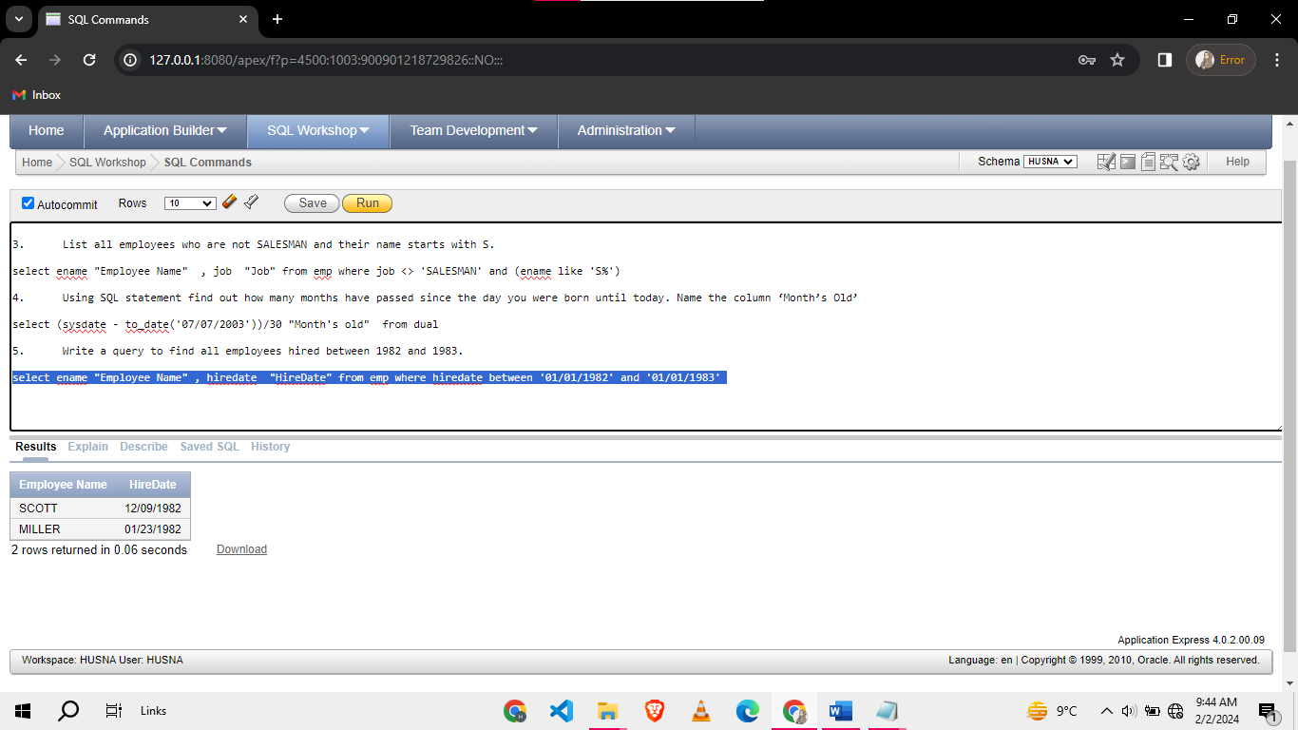

1. I want to find all the departments in which my company employees work. Write a query to list all departments numbers without any duplicates.

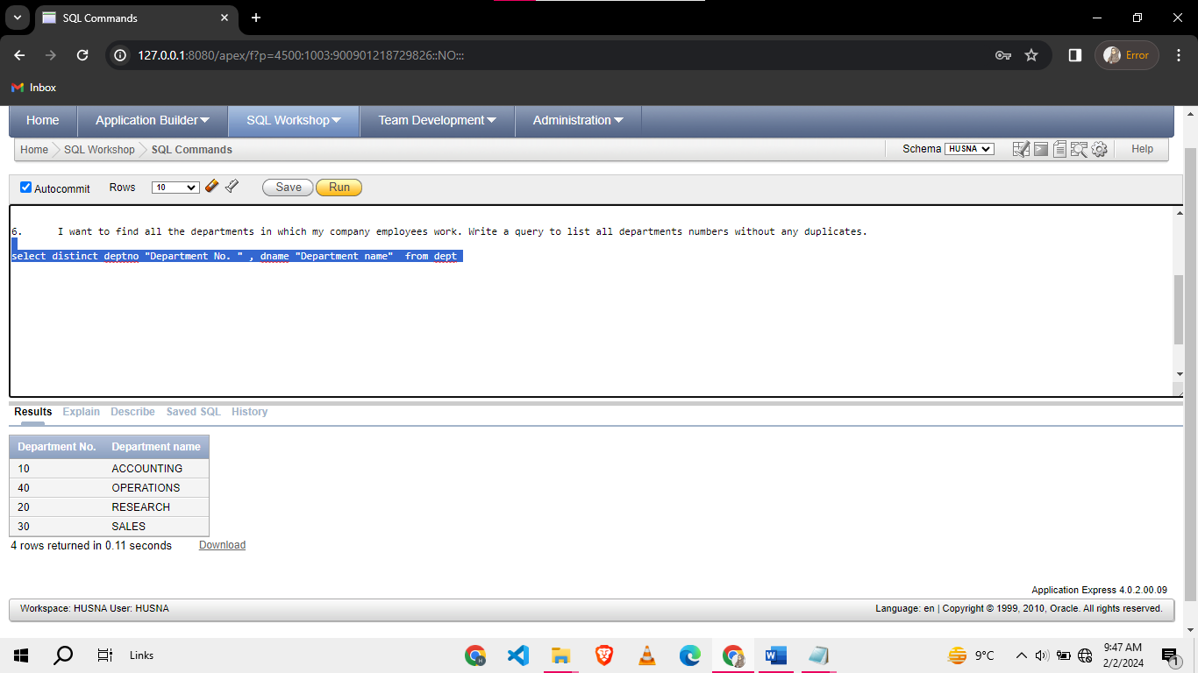

1. Write a query to find all employees whose contains a letter 'A'.

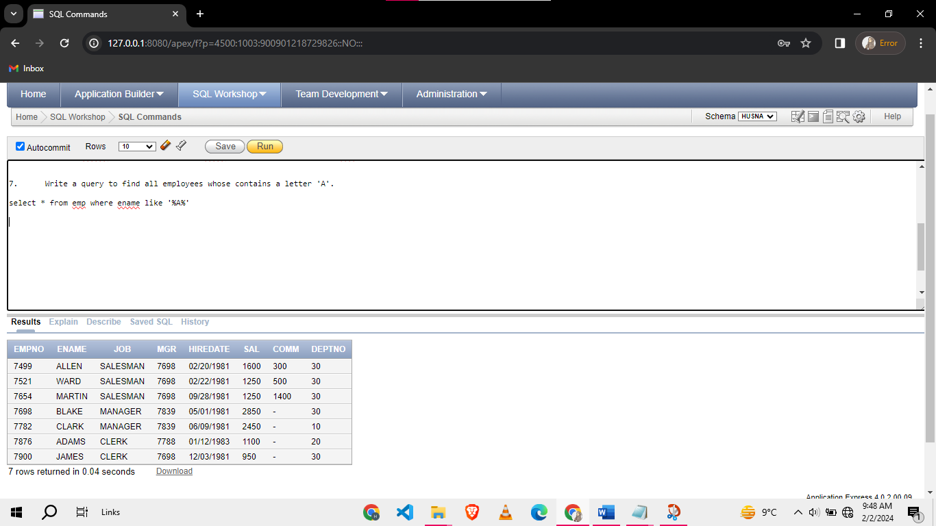

1. Write a query to find all employees with no commission.

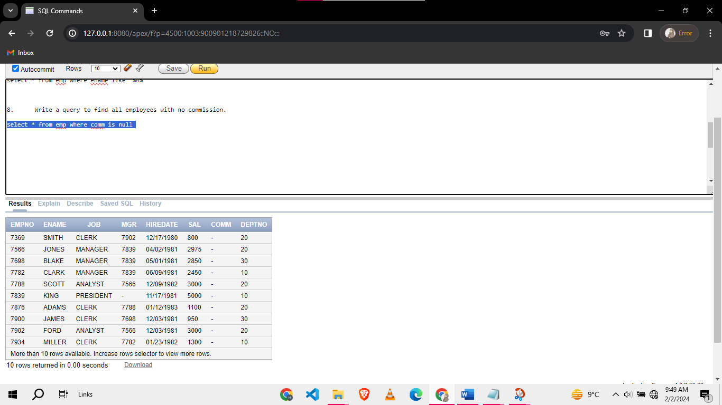

1. Write a query to display employee names in alphabetical order.

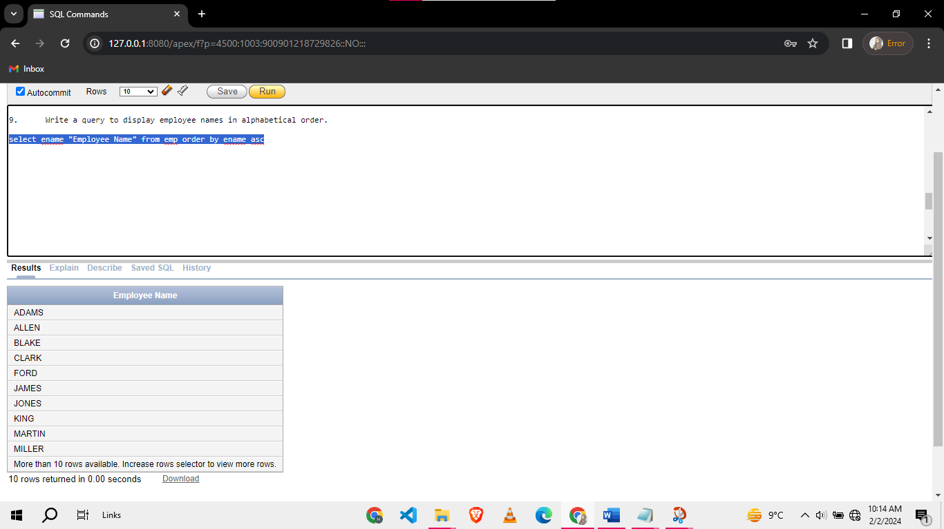

1. Write a query to find all unique job titles which contain a letter ‘S’.

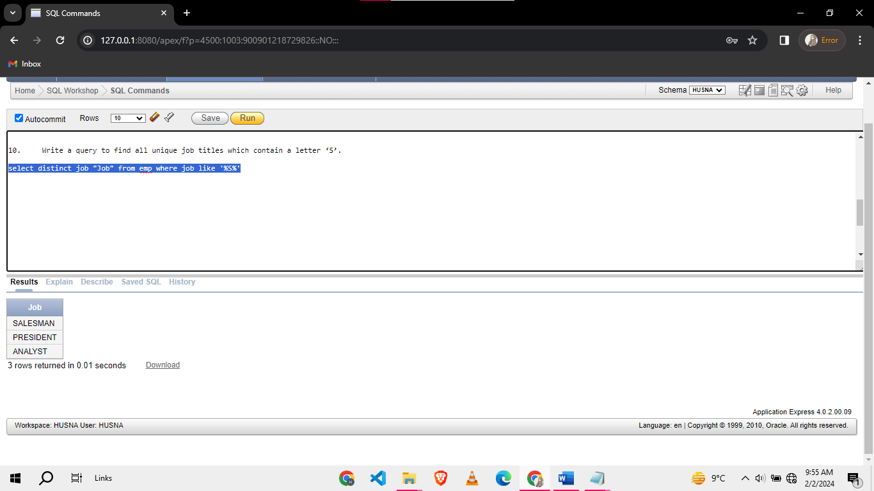

1. Write a query to calculate the total salary of all employees in department 30, including their commissions.

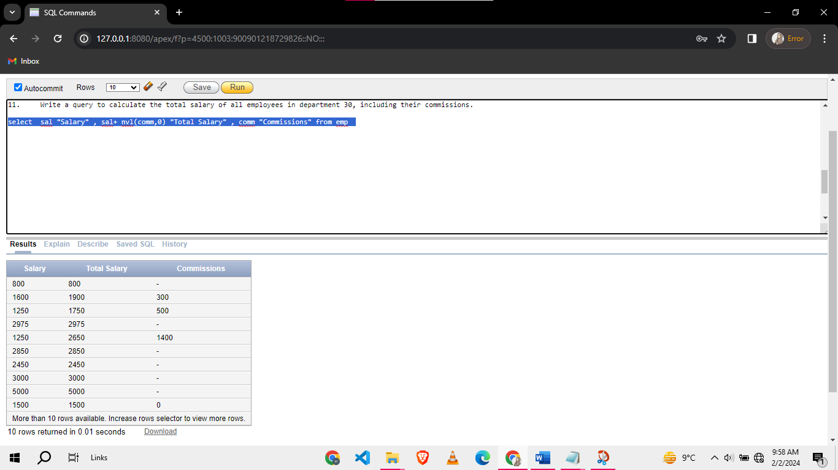

1. Find all employees with annual Sal greater than 20k.

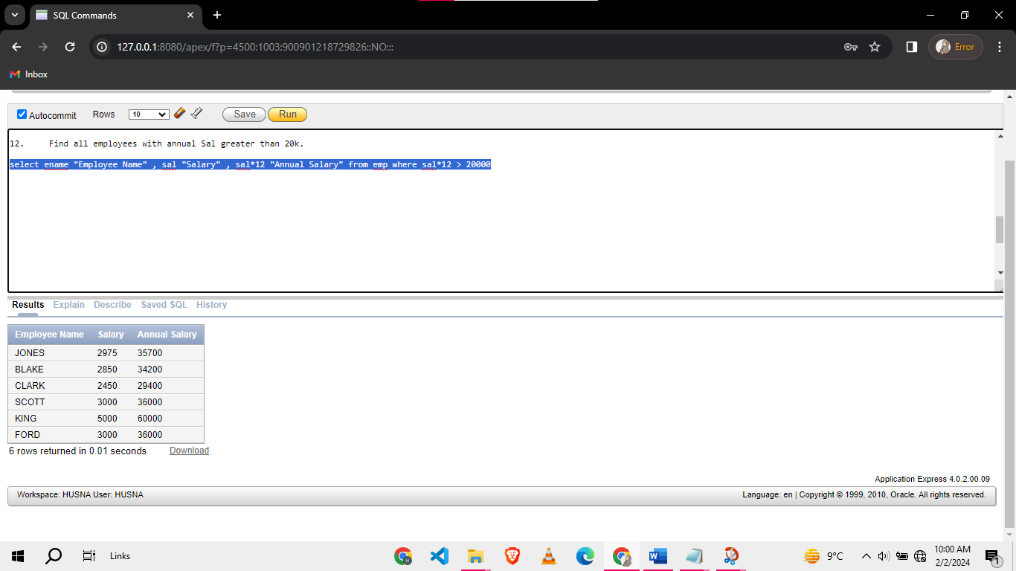

1. Display All the salaries of the employees without any duplicates in descending order.

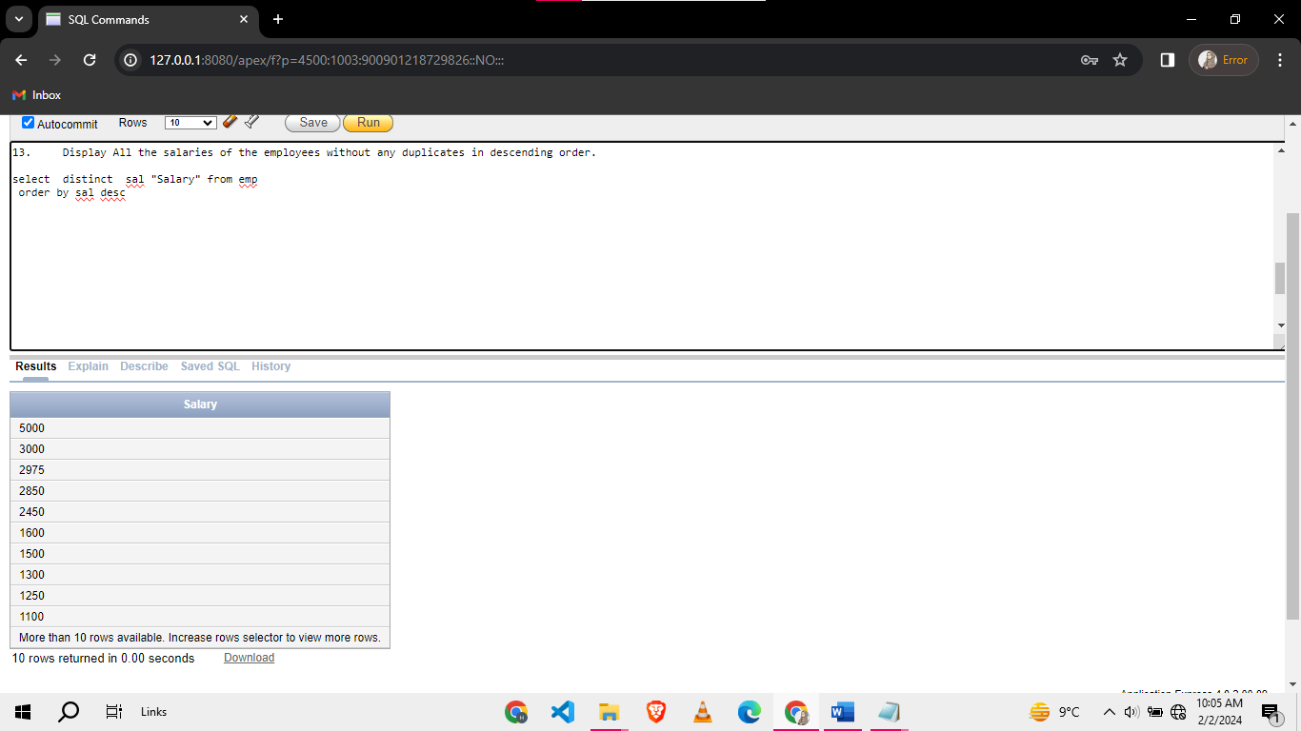

1. List all employees who receive comm, and their comm is more than 15% of their salaries.

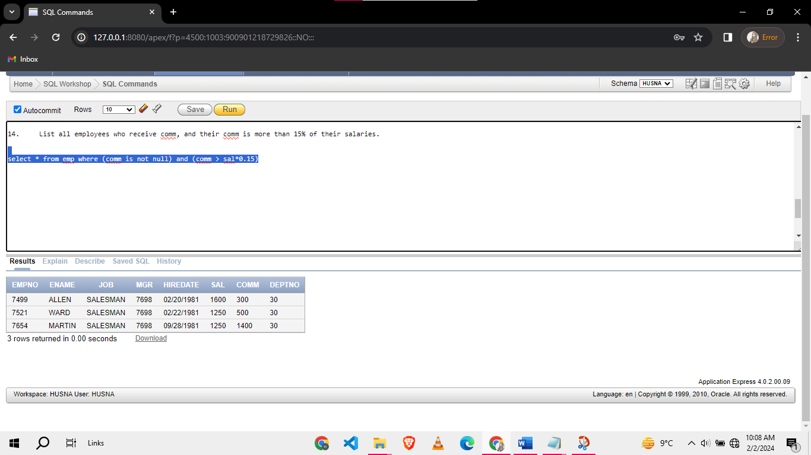

1. List the top 5 highest paid employees.

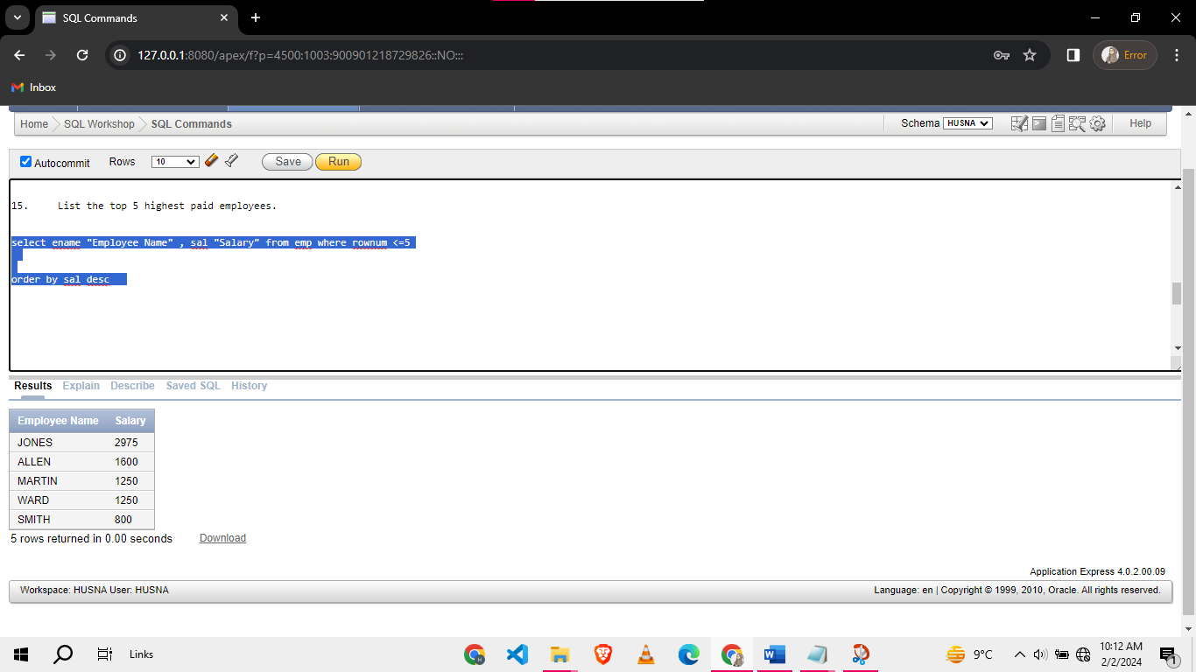

**Task 02: [10 Marks]**

1. Write a query to find all employees who are working in department 20 and hired in year 1980 and display 500, if there commission is null.

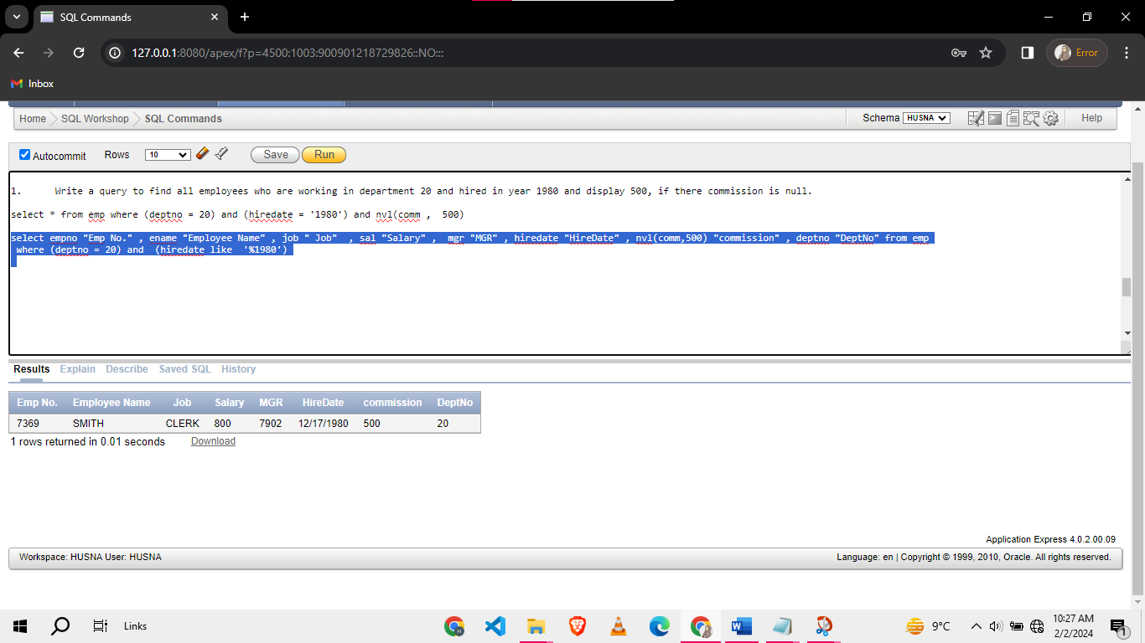

1. List all employees working in departments 10 and 20, who are either managers or analysts, hired between 1980 and 1981, with a commission less than 100 or no commission, and whose names start with 'S'.

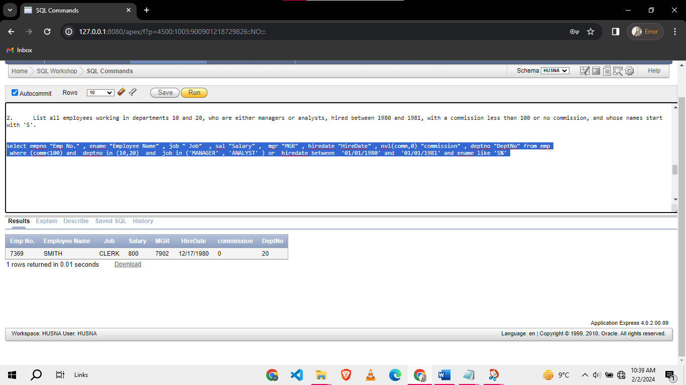

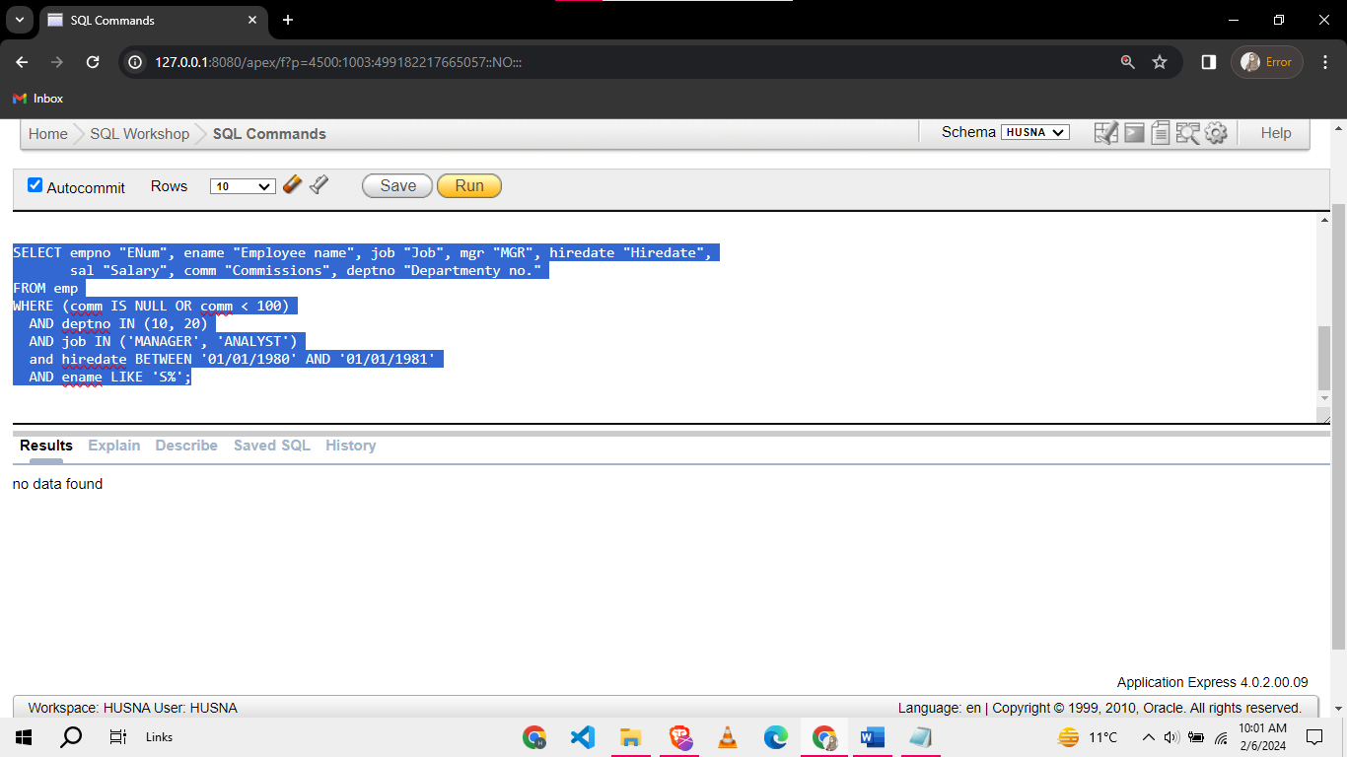

1. The management has decided to award **bonus** to its employees. The **bonus** equals to 50% of sal+comm for the employees whose comm is not null. For the rest of the employees, bonus equal to 50% of sal+200. The query should display ename, job, sal, comm, and bonus.

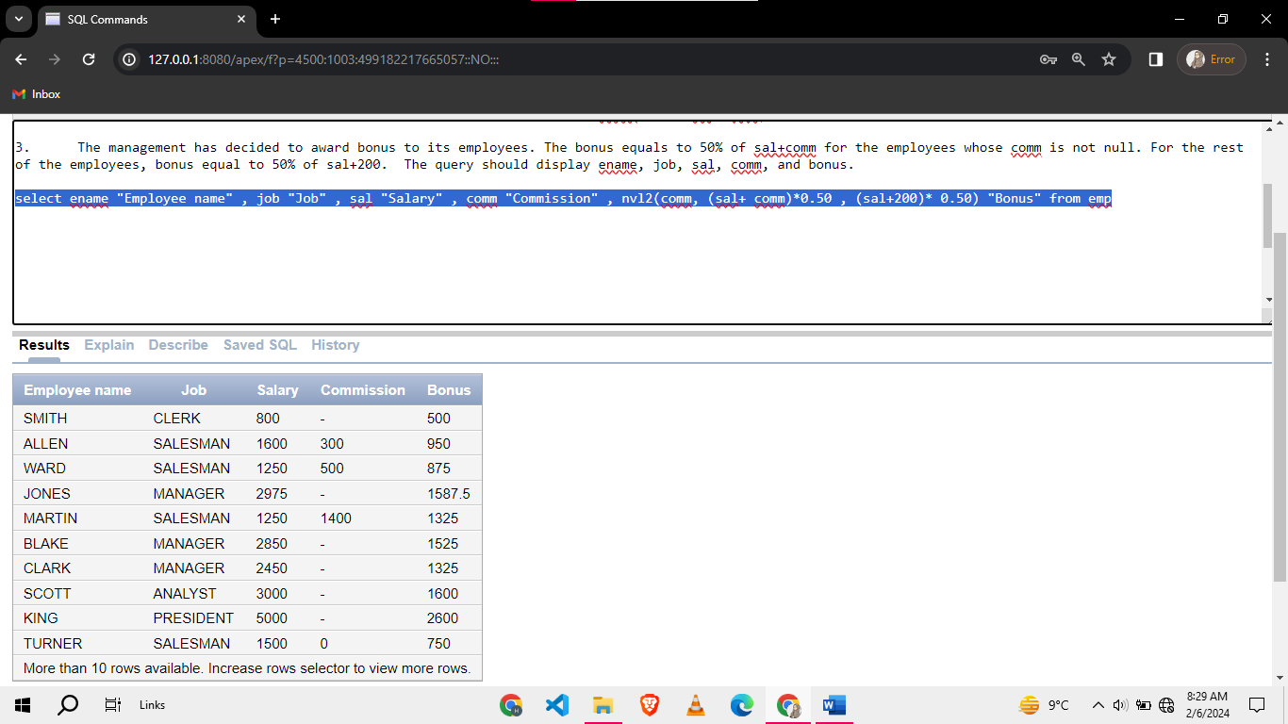

1. Display all employees who have more than only ‘A’ letter in their names.

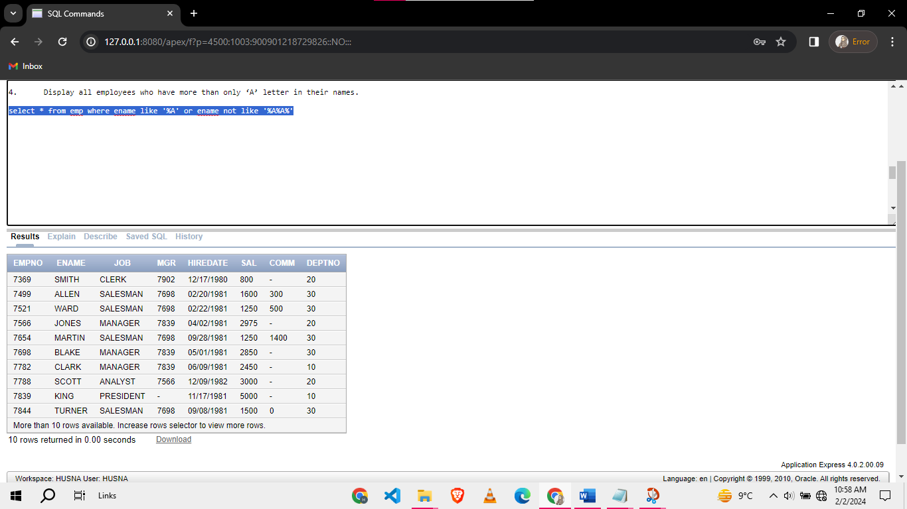

1. Write a query to find employees whose job is either 'CLERK' or 'ANALYST' and whose names contain the letter 'E'. Order the results by their hire date in descending order.

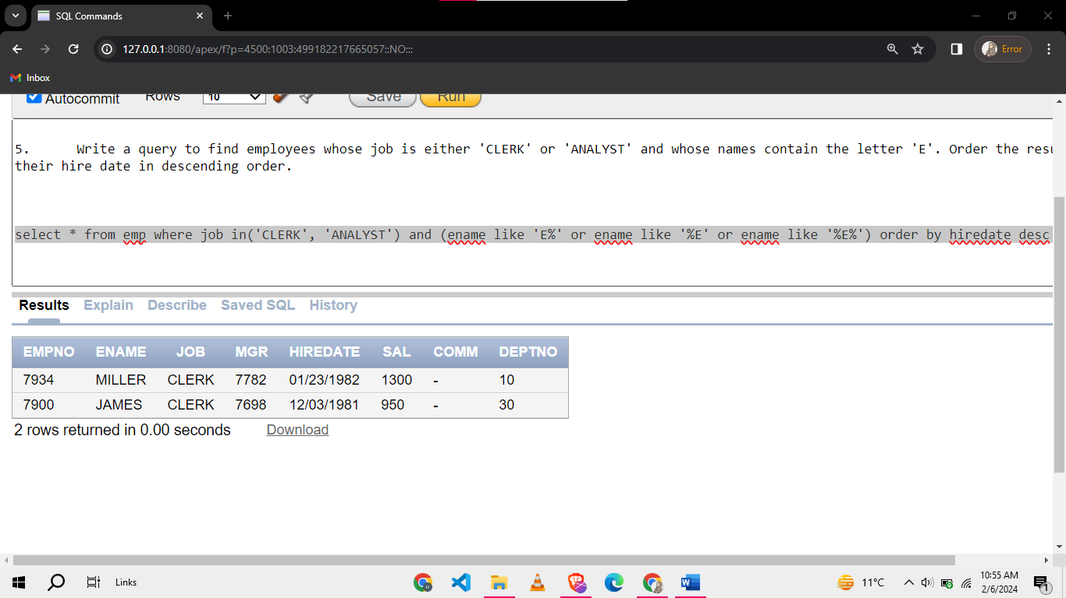

**Task 03: [15 Marks]**

1. Write a query to find employees who were hired either in January or December. Display their names, job titles, and hire dates. Order the results by hire date in descending order.

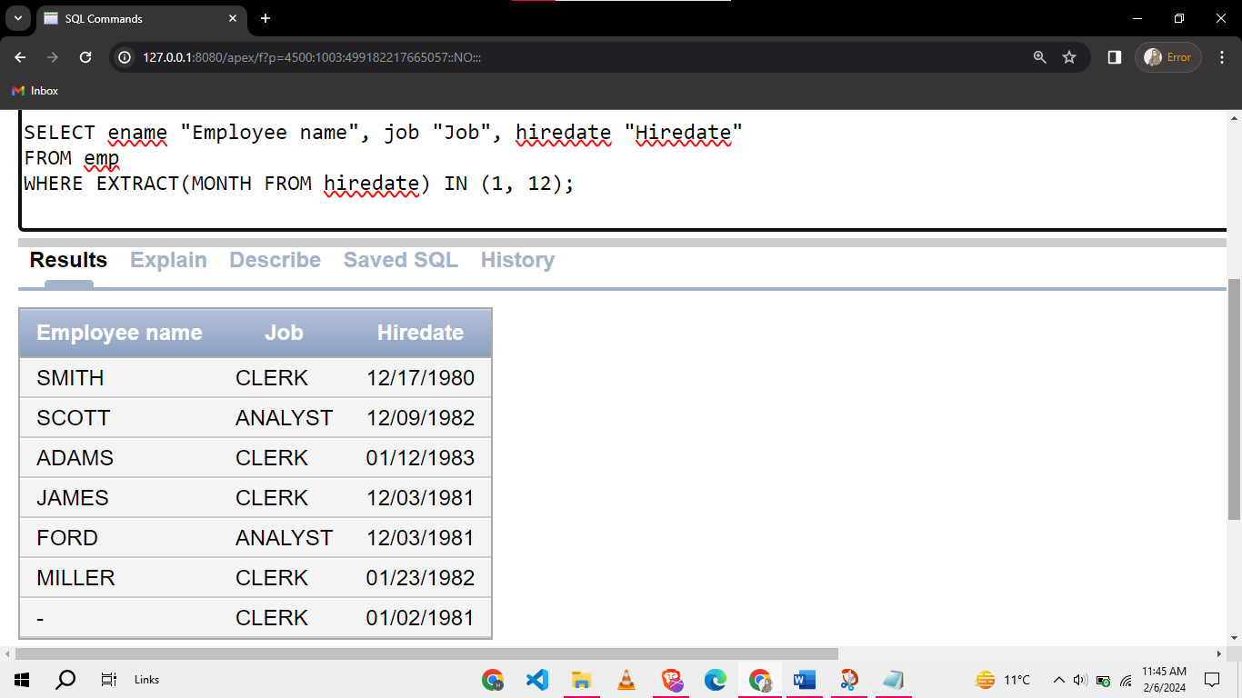

1. Display the names, Sal, comm and combined Sal of employees from emp table and order your output by name in decreasing order by alphabet. The output snippet is given your program should display same results as below. Figuring out the method is part of your question.

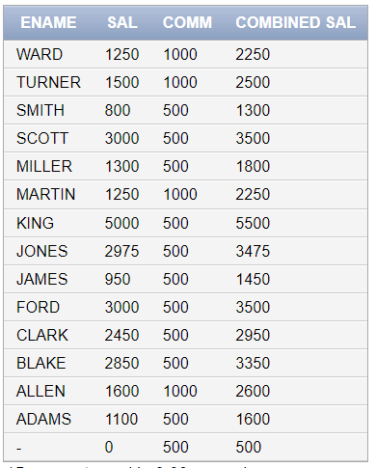

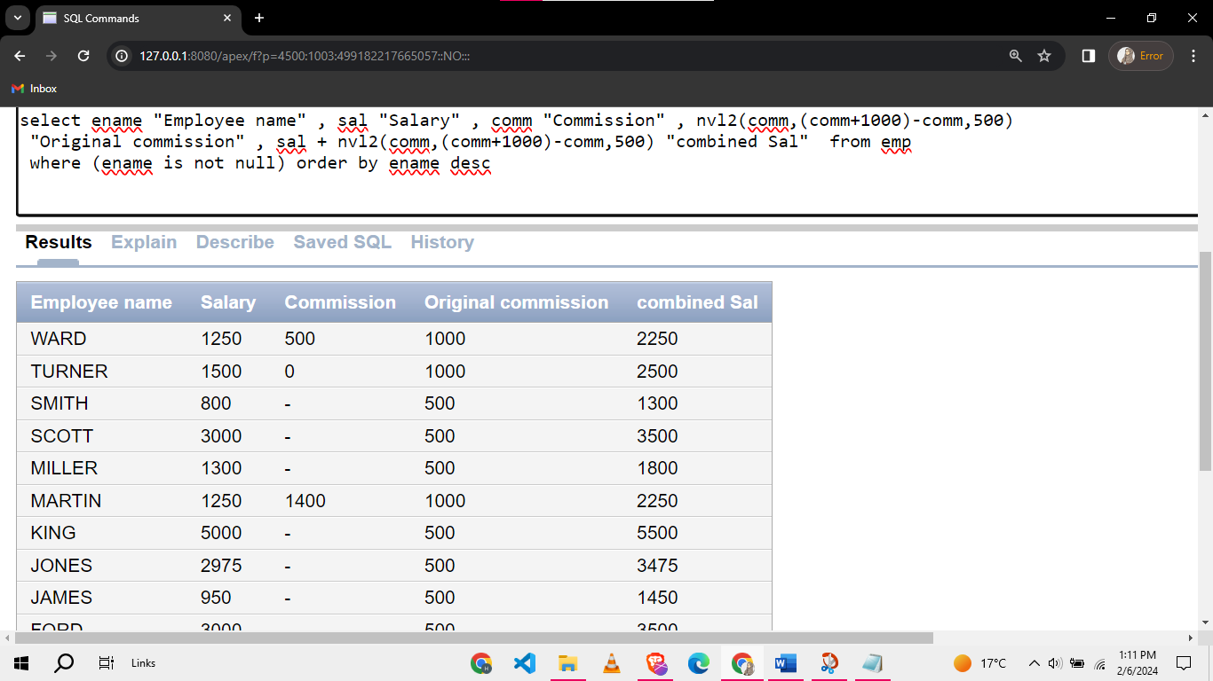

1. Imagine you are tasked with creating a comprehensive budget report for an employee, let's say, "KING" based on the information available in the EMP table. The salary mentioned in the EMP table is considered for a full month's work with 30 days. Suppose that KING worked for the company for 22 days in a certain month. Compute the actual monthly salary for KING based on the number of working days. Use the computed salary of KING to compute the following:
   1. Medical Allowance @ 0.2% of the computed salary.
   2. Travelling Expenses @ 0.13% of the computed salary.
   3. Household Expenses @ 0.3% of the computed salary.
   4. Other Expenses @ 0.4% of the computed salary

Your task is to write an SQL query to perform these computations for King and present the results in a clear and organized manner to allow him see how much he spend how much he earns and how much he saves per month.

**Budget Overview:**

* + 1. **Total Earnings**
    2. **Total Deductions**
    3. **Net Savings (Earnings minus Deductions)**

To avoid any mess you can use **round()** func the way is like “**select round(sal/100) from emp”** to round off any number



1. Display the intro of employees as given in example output. The output should be like:

“I am <ename> and I work as <job>”. If the employee has no name then your program should display the statement including his deptno and Sal as shown in picture below.

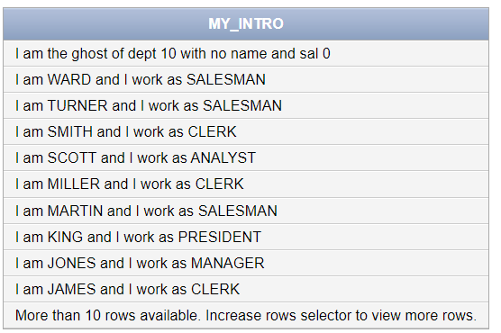

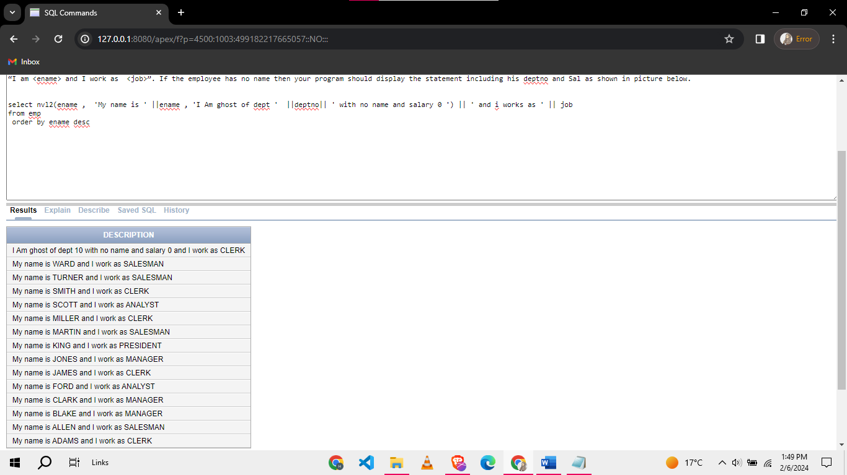

**Task 04: [5 Marks]**

**Viva-Voce.**